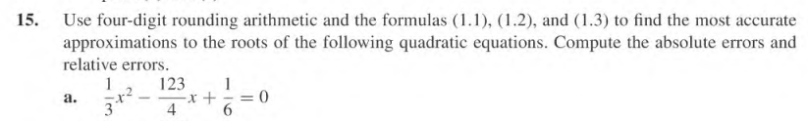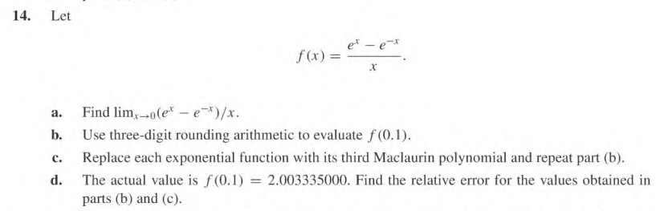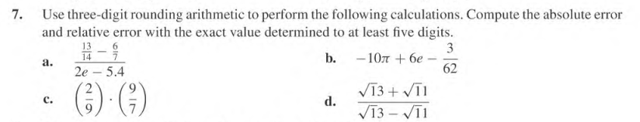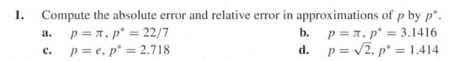**Chapter 1.2**

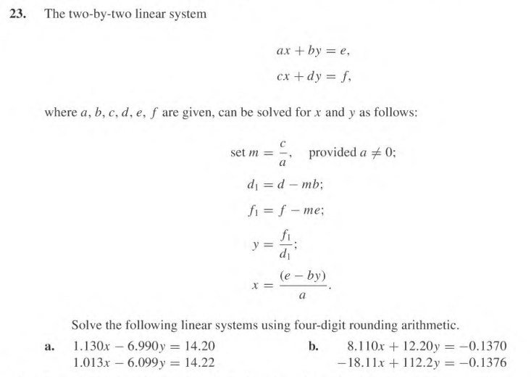

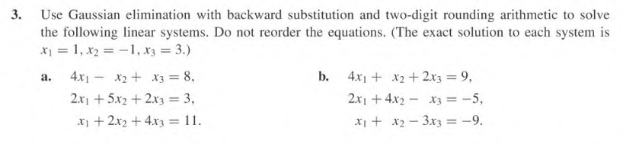**Chapter 6.1**

**Chapter 6.2**

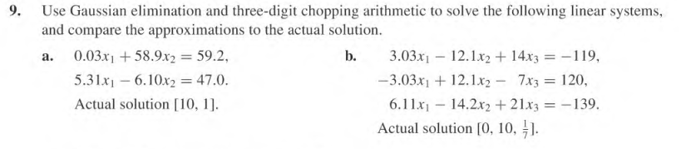* Try with and without partial pivoting

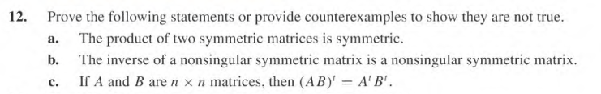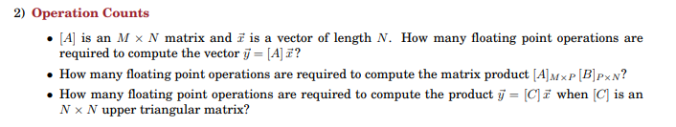

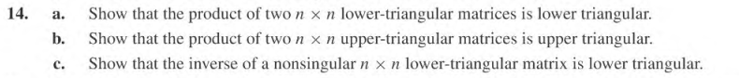

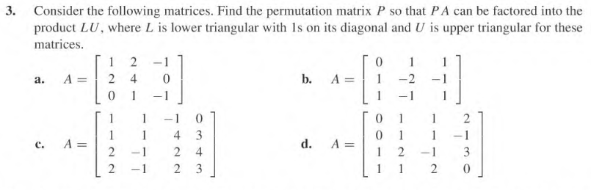**Chapter 6.5**

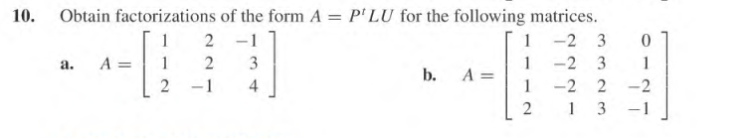

**Chapter 2.1**

*only do several iterations…

**Chapter 2.3**

*only do several iterations…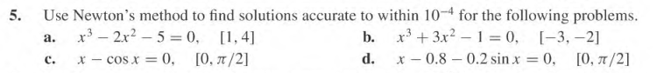

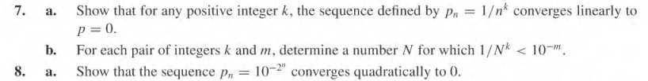**Chapter 2.4**

**Chapter 3.1**





**Chapter 3.5**

